**THE WEB**

**1. A typical web page**

**B. Read text and label the features on the screenshot the terms in bold**

**A typical web page**

At the top of the page is the URL address. URL means Uniform Resource Locator - the address of a file on the Internet. A typical URL looks like this:

http://www.bbc.co.uk/radio/

In this URL, http:// means Hypertext Transfer Protocol and tells the program to look for a web page_ www means world wide web. bbc.co.uk is the domain name of the server that hosts the website - a company based in the UK; other top-level domains are tom (commercial site), .edu (education), .org (organization) or net (network); radio is the directory path where the web page is located The parts of the URL are separated by (dot), / (slash) and : (colon). Some sites begin fttp://, a file transfer protocol used to copy files from one computer to another.

The toolbar shows all the navigation icons, which let you go back one page or go forward one page. You can also go to the home page or stop the current transfer when the circuits are busy.

Tab buttons let you view different sites at the same time, and the built-in search box helps you look for information. If the feed button lights up, it means the site offers RSS feeds, so you can automatically receive updates. When a web page won't load, you can refresh the current page. meaning the page reloads (downloads again). if you want to mark a website address so that you can easily revisit the page at a later time, you can add it to your favourites (favorites in American English), or bookmark it. When you want to visit it again you simply click show favourites.

On the web page itself, most sites feature dickable image links and clickable hypertext links. Together, these are known as hyperlrnks and take you to other web pages when clicked

**C. Listen to three internet addresses and whrite them down.**

**1.** http://www.cambridge.org/elt

**2**. ftp://ftp.ftpplanet.com

**3** http://www.britannica.com/heritage

**2.The collectives of cyberspace**

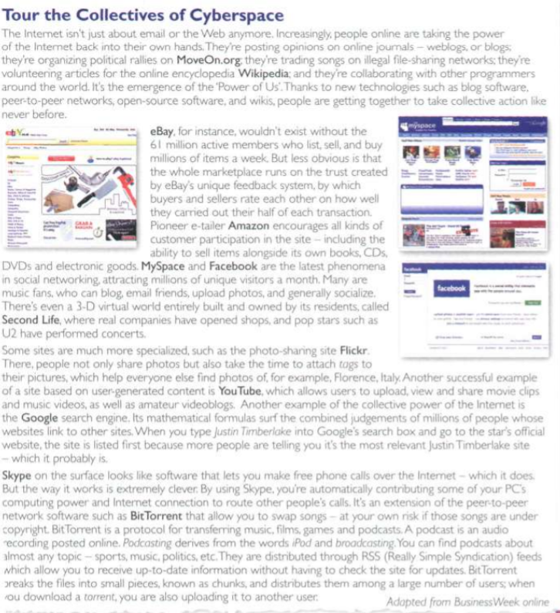

**A. Read the article and find websites for the following tasks.**

1 to search for information on the Web Google

2 to buy books and DVDs Amazon

3 to participate in political campaigns MoveOn

4 to view and exchange video clips YouTube

5 to manage and share personal photos using tags Flickr

6 to buy and sell personal items in online auctions Ebay

7 to download music and movies, sometimes illegally BitTorrent

**B.Read the article again and match the sentence beginnings (1-5) with the correct endings (a-e).**

**1** dog. is an electronic journal **e** that displays in chronological order the postings of one or more people

**2** A peer-to-peer system allows

**c** users to share files on their computers.

**3** You can use a search engine to find

**a** web pages on a particular subject,

**4** Bit-Torrent is a peer-to-peer protocol used

**b** for downloading files over the Internet.

**5** RSS keeps you constantly informed

**d** about fresh, new content on your favourite websites.

**C.Find words in the article with the following meanings.**

**1** apen-source, ealtable web pages (lines 5-10)

wikis

**2** the same as electronic retailer, or online store (lines 10-15)

e-tailer

**3** a blog that includes video (lines 25-30)

videoblog

**4** a program that allows you to make voice and video calls from a computer (lines 30-35)

Skype

**5** an audio broadcast distributed over the Internet (lines 35-40)

Podcast

**HELP box**

**Collocations 2**

A collocation Is a pair or group of words that are often used together. For example, we say **make phone calls**, not **do phone calls**.

Here are some common types of collocation:

• verb + noun (see Unit 1 )

**surf the Web download music**

• verb + particle

**hack into a computer log onto bank account**

• adverb + adjective

**highly sensitive** information

**freely available** on the Web

• adjective + noun

**mathematical formulas**

**up-to-date information**

The word **online** collocates with other words and can function as adjective or adverb.

Adjective: They post opinions on **online** journals.

Adverb: A podcast is an audio recording posted **online**

**3.Language work: collocations 2**

**A. Look at the HELP box on page 87 and then match the words on the left (1-6) with the words on the right (a-f) to make collocations. There may be more than one possible answer.**

1 online (a-b) a friends

2 take (b-c) b photos

3 email (a-b) c action

4 upload (b) d website

5 portable (f) e encyclopedia

6 official (d) f player

**C. Find the collocations in these sentences and say what type they are.**

**1** Once you are Online, you can browse the Web, visit chat rooms or send and receive emails.

be online (verb + adv), browse the Web (verb + noun), visit chat rooms (verb + noun), send and receive emails (verb + noun)

**2** Instant messaging can be a great way to communicate with friends.

Instant messaging (adjective + noun), great way (adjective + noun),

communicate with (verb + particle)

**3** This software may not be fully compatible with older operating systems.

fully compatible (adverb + adjective)

**4** Most webcams plug into a USB port.

plug into (verb + particle)

**5** This highly addictive game will keep you playing for hours.

highly addictive (adverb + adjective); addictive game (adjective + noun)

**6** Companies are starting to use virtual reality on their websites.

virtual reality (adjective + noun)

**4. E-commerce and online banking**

**A.Listen to two extracts from a monthly podcast called Money Matters. What is each speaker talking about?**

Speaker 1 e-commerce Speaker 2 online banking

**B.Listen again and make notes under these headings.**

**Speaker 1**

Things people buy online

-Books, music and airline tickets

Steps for buying online

-Enter a site dedicated to e-commerce and browse their products

-Put the items you want to buy into a virtual shopping cart

-Enter your personal data you may have to log in with a usemame and a password if you have an account with them • Confirm the order and log out

Precautions

-Read all product information clearly

-Check whether you can cancel the purchase

-Keep a printout of your order

-Do not give private information that is not directly required for your transaction.

-Only give your credit card number to suppliers that you know and trust

**Speaker 2**

**Things you can do with online banking**

-Access an account, check balances, pay bills, transfer funds at any time to anywhere

**Biggest issue with online banking**

-Security and cybercrime

**Precautions**

-Never give your PIN to anyone and don't even write it down

-Be careful of phishing.

-Don't provide any sensitive information

-Don't forget to have anti-spy software

**C. Complete the extracts with words from the box**

**1** Occasionally I also buy things on internet auction sell things to the highest bidder.

**2** First you enter a site dedicated to e-commerce and browser their products.

**3** Then you put the items you want to buy into a virtual shopping cart -a program that lets you select the products and buy with a credit card.

**4** You may have to log in with a username and a password ...

**5** ... for some transactions, you will be required to use a TAN, a transaction authorization number.

**6** Be aware of phishing - you may receive fake emails claiming to be from your bank and asking for personal information or account details in an attempt to steal your identity.

**5. Language work: the prefixes e- and cyber-**

**HELP box**

**The prefixes e- and cyber-**

• The **e-** prefix means electronic, and we add it to activities that take place on computers or online, for example **e-business /e-commerce** - business car conducted over the Internet. Other examples include **e-card e-learning, e-zine e-voting e-signature e-assessment e-cash. e-book and e-pal**

There are often spelling variations, with or without a hyphen, so always check your dictionary. •

•The **cyber-** prefix comes from cybernetics, and we use it to describe things related to computer networks, for example **cybercafe** - an internet café. Other examples include **cybercrime, cyberculture, cybersiacker and cyberspace**

**Look at the HELP box and then complete these sentences.**

**1** A is an employee who uses his company's Internet connection during work hours to chat with friends, play games, etc

Cyberslaker

**2** An is a postcard sent via the Internet.

e-card

**3** An is a small magazine or newsletter published online.

e-zine

**4** Ina you can use computers with Internet access for a fee

cybercafe

**5** Examples of include internet fraud. digital piracy, theft of confidential information, etc

cybercrime

**6** In the future, all elections will be carried out using

e-voting

**7** You can now sign legal documents online using an

e-signature

**8** will revolutionise the way we take exams.

e-assessment

**9** can be used on some websites instead of real money to make purchases. It reduces the risk of fraud.

e-cash

**10** An is like the paper version, but in digital form**.**

e-book